**CS4182 Report - Brain computer interfaces**

- AdamO’ Sulivan - 19265808  
- Eryk Wolak - 19277156  
- Padraig Foley - 19232845  
- Gabriel Rigaudie - 19269315

Link to Github: <https://github.com/templerpadi/CS4182-Essay>

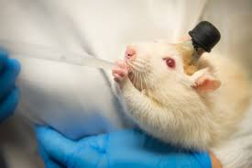An image of early prototypes of BCIs used on lab rats to train them to become more docile.

This rats name was Gerald

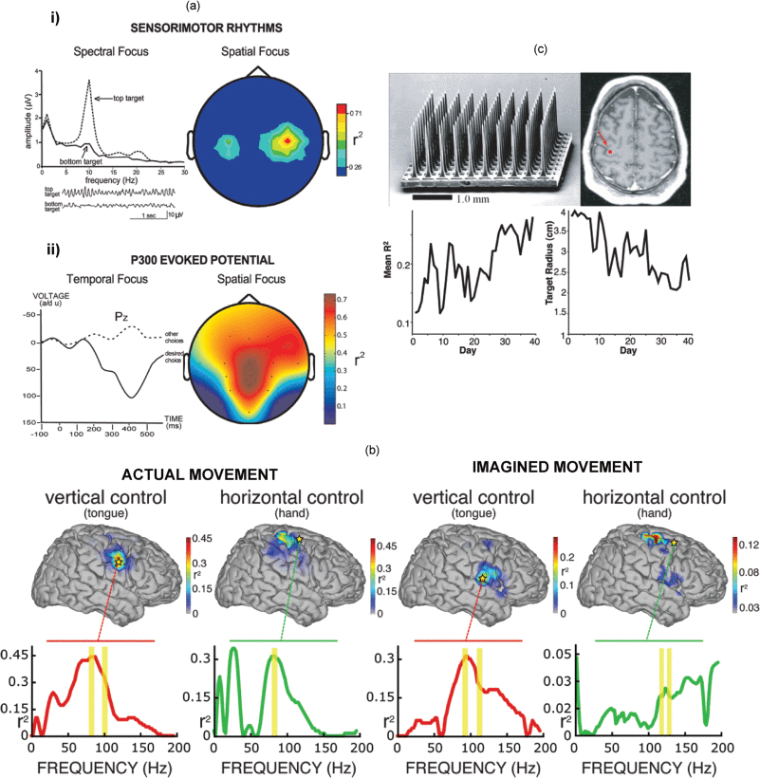Top left: 100-microelectrode array for chronic implantation in human motor cortex to record neuronal action potentials and/or local field potentials.

Top right: placement of an electrode array in the human motor cortex.

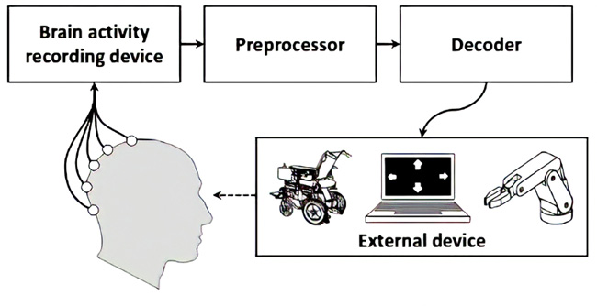Brain activity measurement   
(Eg: fNIRS, fMRI, EEG, etc.)

Preprocessor  
 (Eg: Biomarkers, Coherence, etc)

BCI-based application  
(Eg: Controlling software, Robot, etc.)

Neurofeedback  
(Eg: Visual, Audible, Haptic, etc.)